* What tools did you use for each step? (Python, SQL, Excel, etc)

For analyse local and global temperature data and getting a moving average used excel. And compare the weather trends in Line chart format used Tableau.

SQL Query:

SELECT

city.year,

city.city,

city.country,

city.avg_temp,

global.avg_temp as "avg_temp_global"

FROM city_data city

INNER JOIN global_data global

on city.year = global.year

WHERE city.city = 'Singapore'

AND city.avg_temp IS NOT NULL

* How did you calculate the moving average?

I used excel for this calculation, First create one column in excel file **ma_10_temp_city** where moving average would be stored, Now go to the cell of 10th ma_10_temp_city column and apply AVERAGE() function like below image

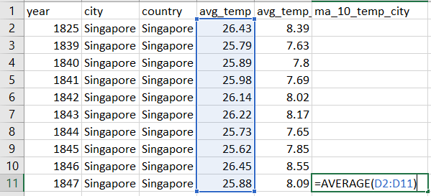

10 Year Moving Average = AVERAGE(1st cell of avg_temp: 10th cell of avg_temp)

* + What were your key considerations when deciding how to visualize the trends?

In Chart X-axis should represent the year and Y-axis should represent the temperature. Green line should represent as global moving average temperature and red line as local moving average temperature.

* **Line chart** with local and global temperature trends

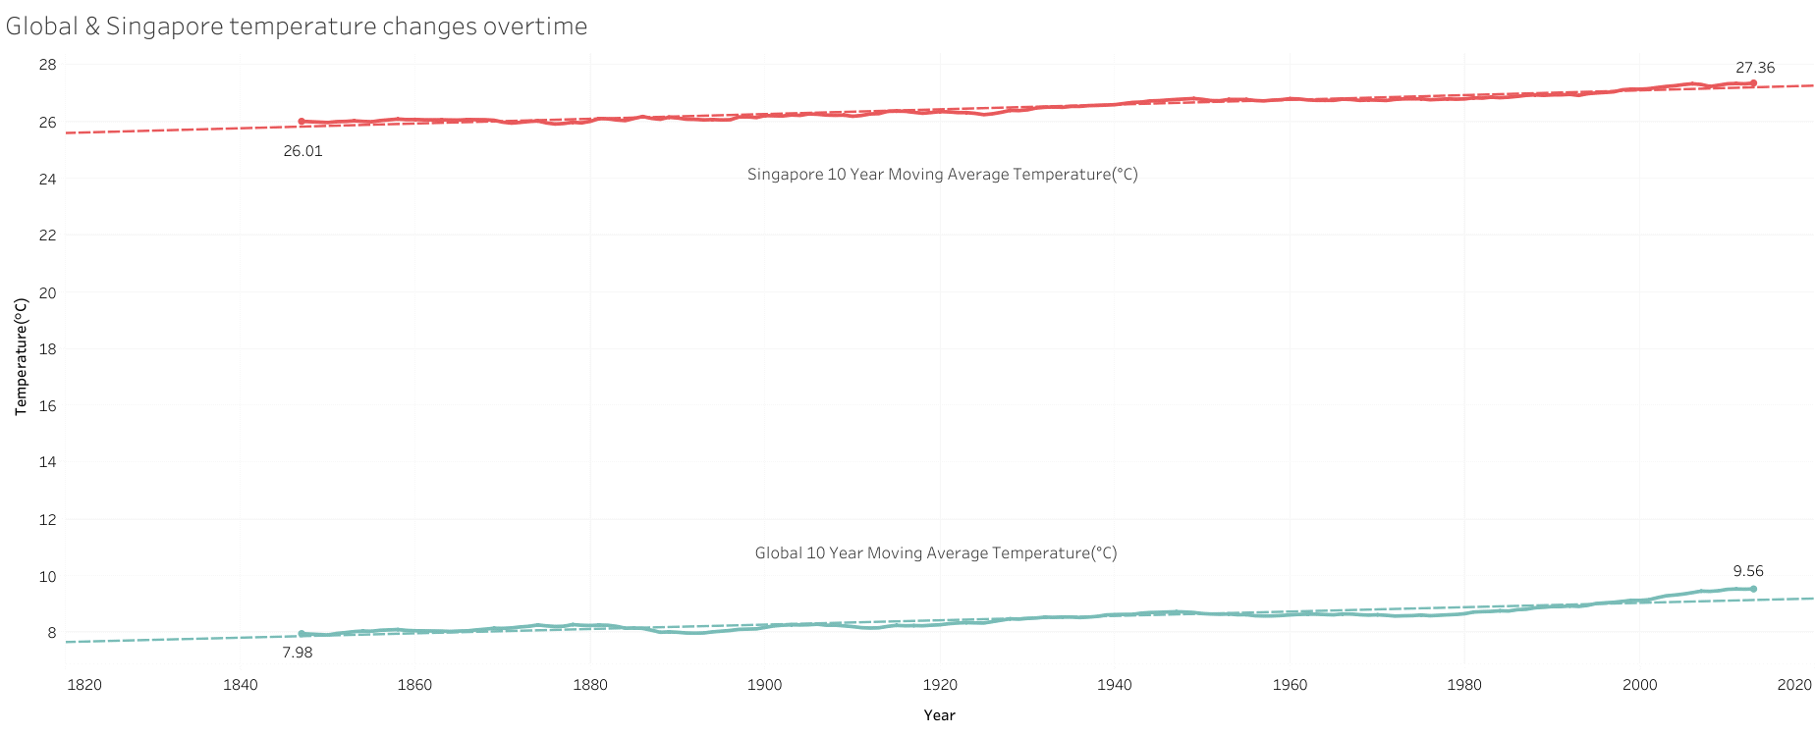

From this chart we get to know that

* Globally temperature increased year by year.
* Comparing to global temperature Singapore having higher temperature.
* Singapore temperature is around 25 to 32 °C humid and hot all the time.
* Year by year Singapore temperature increased around 5% where as the global temperature increased around 20%.
* Using this chart, we can predict that next decade will be hotter if we are not able to manage or control of global warming.